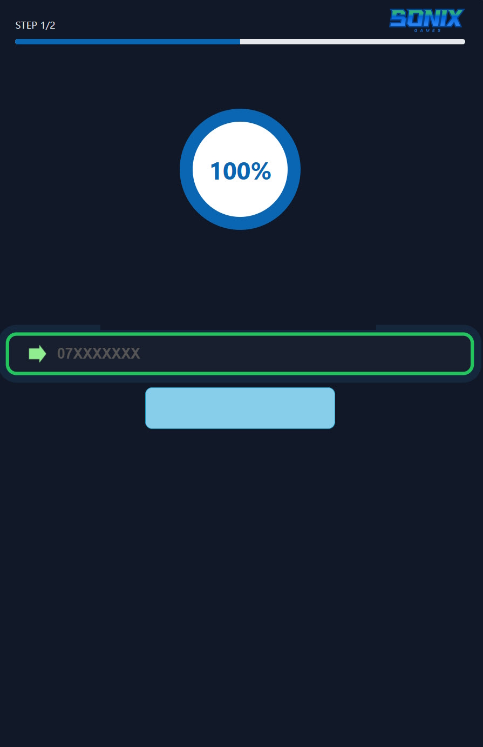

- Welcome to Sonic Games: Games Subscription
- The service price is 0.20 JOD daily on Zain and Umniah, and 0.25 JOD daily on Orange. The subscription will be renewed automatically.
- You can unsubscribe at any time via SMS For Zain subscribers, by sending U50 to 90910, for Umniah send Exit 18 to 98819, for Orange U12 to 98860
- By subscribing to the service, you accept all terms and conditions and agree to share your information with the service provider.
- To benefit from this service, you must be over 18 years old or have obtained permission from your parents or the person authorized to pay your bill.
- .

GET IT NOW
ENTER YOUR MOBILE NUMBER
AR EN

